**Kundali Based Marriage Time Prediction**

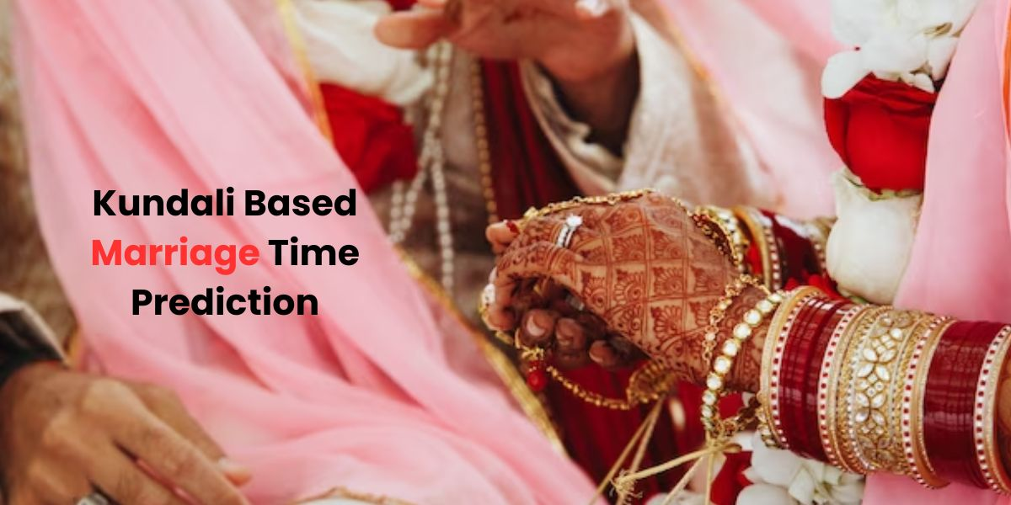

It is possible to determine marriage time through Kundali. While there are many methods available, I have personally identified three methods that give the most reliable results, which we will discuss in detail here. The three most effective methods for accurately predicting marriage date from Kundali are:

Vinshottari Dasha Method

Chara Dasha Method

Gochar or Transit Method

According to [Marriage Prediction](https://bejandaruwalla.com/pages/marriage-prediction), however, for accurate results, it is important to integrate all three methods. Relying on only one or two can lead to errors. The methods discussed below relate specifically to first marriage. Second marriages also involve several variables.

**Can marriage be predicted from Kundali?**

Questions related to marriage and life partners are among the most common questions asked of astrologers. Vedic astrology provides us with robust techniques that enable us to predict marriage based on Kundali. It is important to learn how to take advantage of these techniques. You may try to plan the wedding as per your liking, but if the timing is not favorable to your horoscope, marriage may not be possible. Even if a marriage proposal comes, it may fall apart due to many reasons. Conversely, marriage at the right time may happen quickly and unexpectedly.

**Kundli Matching for Marriage**

Horoscope matching for marriage is a practice that is based on certain cultural and astrological beliefs. Although its significance varies from person to person, it can provide a sense of agreement and calculation of values ​​based on astrological factors. Some people find faith and assurance in this Kundli matching, believing that it can help reduce conflicts. However, it is important to remember that horoscopes alone cannot determine the success of a marriage. Healthy communication, mutual involvement, mutual respect, and understanding are at least equally, if not more, important for a happy and lasting marriage. So, although Kundli matching may be right for some people, it should not override these essential relationship factors.

**Marriage Prediction by Date of Birth**

In Vedic astrology, marriage is a sacred union between two individuals, guided by worldly influences and karmic relationships. It is an important and sensitive turning point in life, symbolizing the union of two souls and families. The astrologer analyzes the planetary positions in the birth charts of both individuals, focusing on the 7th house, its ruler, and aspects, to determine compatibility and marital prospects. Auspicious planets like Venus and Jupiter are considered auspicious for marriage. Vedic astrologers also consider doshas like Mangal Dosha and prescribe remedies to mitigate future challenges. Ultimately, marriage in Vedic astrology is a divine arrangement that reflects luck and worldly harmony in the journey of love and companionship.

**Key Planets for Marriage Time Prediction**

Venus and Rahu have special significance in marriage astrology. Venus, the natural significator of marriage and relationships, can speed up marriage during its dasha period, no matter in which house it is placed. Similarly, Rahu can influence the timing of marriage during its dasha or antardasha, if it is aligned with the marriageable age. This planet has great significance for marriage prediction in astrology.

**Conclusion**

Determining marriage prediction through astrology involves a thorough analysis of planetary positions, the position of houses, and important periods in a person's life. It is essential to understand the influence of planets like Venus, Rahu, and Darakaaraka, as well as the significance of houses like the 7th, 2nd, and 11th. Considering factors like planetary combinations, possible delays, and favorable periods, consulting and [talk to astrologers](https://bejandaruwalla.com/pages/astrology-consultation-online) can provide valuable information about the timing of marriage. By carefully examining these astrological indicators, individuals can gain clarity and guidance about their marital journey.