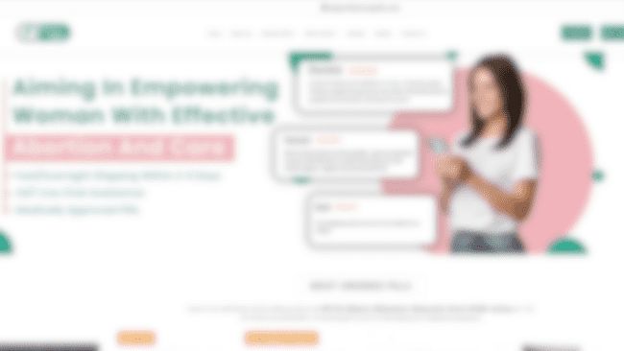

ABORTION PILL PACK

[www.privacypillrx.com](http://www.privacypillrx.com/)

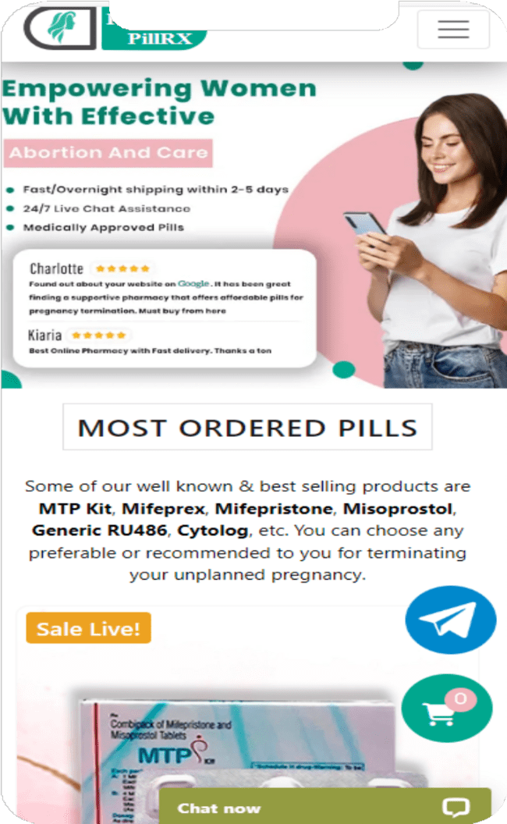

PRIVACYPILLRX

## [PrivacyPillRx](https://www.privacypillrx.com/) is a renowned healthcare store for women. It is well-trusted for providing pharmaceutical products to manage an unplanned pregnancy early. We have cost- effective pills such as MTP Kit, Mifeprex, Generic RU486, Cytolog, and more. Our priority is to safeguard your interests.

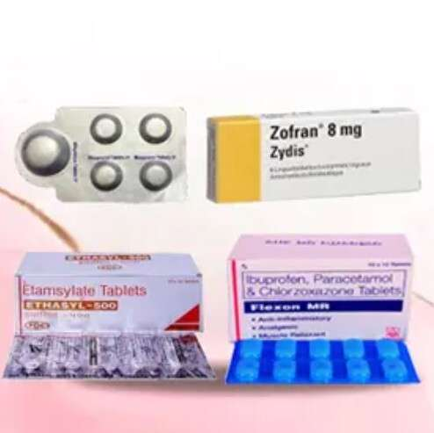

What is an Abortion pill pack?

A combination of medicines used to end an early pregnancy is commonly referred to as an abortion pill pack. This [abortion pill pack](https://www.privacypillrx.com/buy-abortion-pill-pack-online) contains a combination of mifepristone and misoprostol.

[www.privacypillrx.com](http://www.privacypillrx.com/)



HOW DOES THE ABORTION PILL PACK WORK?

### Mifepristone: The medicine works by preventing progesterone from being produced, which is necessary for a pregnancy to progress.

Mifepristone causes the uterine lining to rupture by preventing progesterone, which causes the embryo or fetus to separate from the uterine wall.

Misoprostol: This medicine is often used between 24 and 48 hours

### following mifepristone. The uterus contracts as a result of misoprostol, pushing out everything inside, including the embryo or fetus.

[www.privacypillrx.com](http://www.privacypillrx.com/)

WHAT IS THE DOSAGE OF ABP?

 Initiate the abortion process by taking the initial Mifepristone pill orally with water. Following a time span of 24 to 48 hours, proceed with the Misoprostol pills. Begin by placing 2 Misoprostol pills beneath the tongue, allowing them to dissolve within the mouth or between the cheeks and gums. After a 3-hour interval, administer the remaining Misoprostol pills in the same manner, positioning them under the tongue or within the cheek area.

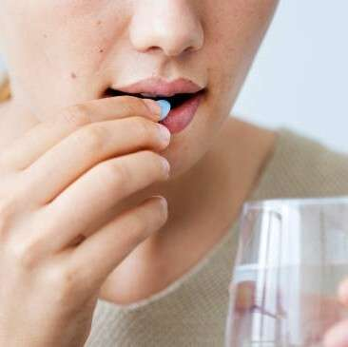

 To counteract potential vomiting, it is advisable to consume the Zofran or Ondansetron pill just before taking the misoprostol pills.

 To alleviate cramping, consider using Flexon-MR at the onset of abdominal cramps.

 In the event of increased bleeding, promptly utilize ethamsylate.

PRECAUTIONS If you are contemplating the utilization of the Abortion Pill Pack for



terminating a pregnancy, it is of utmost importance to initiate the

process with an ultrasound examination. This step is necessary to verify the pregnancy type, ensuring that it is located within the uterus, as these abortion pills are not effective in cases of ectopic pregnancy.

Opting for an abortion in a home setting is advisable solely for individuals between the ages of 18 and 35. If your age doesn't fall within this range, it is advisable to refrain from attempting a home abortion and instead seek professional medical guidance.

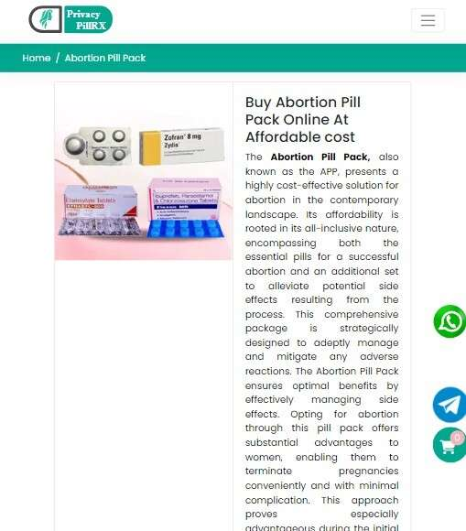

WHERE YOU CAN BUY AN ABORTION PILL PACK ONLINE?



You can [buy Abortion pill pack online](https://www.privacypillrx.com/buy-abortion-pill-pack-online) from privacypillrx website at pocket friendly prices. We are an online abortion pills seller we provide abortion pills online in all 50 states of the US. Also, you can get these medicines by credit card.

[www.privacypillrx.com](http://www.privacypillrx.com/)



# CONTACT US

[support@privacypillrx.com](mailto:support@privacypillrx.com)

[www.privacypillrx.com](http://www.privacypillrx.com/)

<https://www.instagram.com/privacypillrx/>

<https://twitter.com/Privacypillrx>



**THANK YOU!**