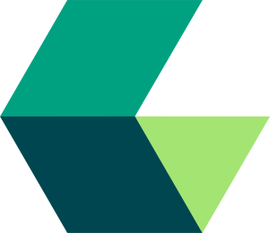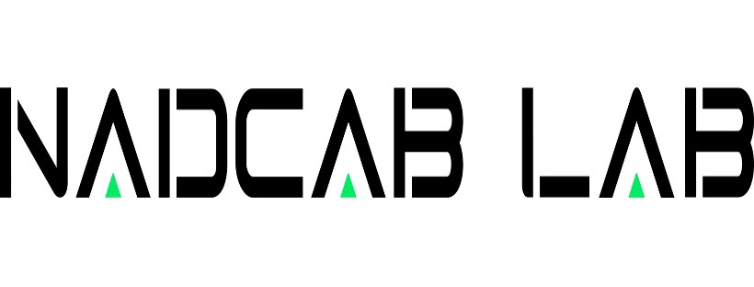

Custom Blockchain Development Company: Pioneering Future-Proof Solutions|Nadcab Labs
Blockchain technology has become a keystone of innovation in the rapidly changing digital landscape, offering exceptional security, transparency, and performance. Custom blockchain development is becoming more and more in demand as businesses and sectors move toward decentralized solutions. Nadcab Labs specializes in creating one-of-a-kind blockchain solutions that meet the specific needs of organizations while guaranteeing sustainability, scalability, and interoperability. The core of these agencies, the services they give, and the transformative potential they uphold for businesses worldwide are all explored in this article.
What is a Custom Blockchain Development Company?
A custom blockchain development company is a tech-pushed corporation that specializes in building customized blockchain-based totally applications and infrastructure. Unlike off-the-shelf blockchain solutions, custom development focuses on creating specific capabilities and functionalities that align with the client's commercial enterprise model, operational needs, and lengthy-time period targets. These organizations harness the energy of the blockchain era to increase secure, efficient, and transparent structures for various industries, such as finance, healthcare, delivery chain, and the past.
Blockchain Solutions Provided with the aid of Nadcab Labs
1. Blockchain networks:
At its core, blockchain networks are decentralized digital ledgers that store transactions across multiple computer systems in a way that ensures each transaction can be verified and is safe from manipulation. Beyond virtual currencies, this generation—which powers cryptocurrencies like Bitcoin and Ethereum—has far-reaching uses, including supply chain management and virtual identity verification, among other things. Let's examine the many types of blockchain networks and their unique features:
- Public Blockchains - Examples: Bitcoin, Ethereum, Litecoin
- Private Blockchains - Examples: Hyperledger Fabric, Corda
- Consortium Blockchains - Examples: Quorum, R3
- Hybrid Blockchains - Examples: Dragonchain
2. Asset tokenization answers: Asset tokenization transforms finance by transforming physical, worldwide real estate into digital tokens on a blockchain, enabling fractional ownership, increased liquidity, and access to a global marketplace. It promises to democratize funding options and transform the financial environment by utilizing blockchain's transparency and smart contracts to lower costs, speed up transactions, and enhance regulatory compliance.
3. Blockchain-based market platforms: Blockchain-driven market structures use tokenization, smart contracts, and decentralization to transform transactions and provide stable, transparent, and environmentally friendly worldwide asset buying and selling without the need for middlemen. They force innovation in industries like finance, the arts, and supply chains with their lower costs, increased market access, and increased safety. This heralds a revolutionary change toward inclusive and environmentally friendly global marketplace structures, despite technological and legislative obstacles.
4. Smart contracts: Smart contracts function as automatic agreements in custom blockchain development, carrying out transactions and taking actions in response to predetermined scenarios that are stored in code. By customizing blockchain solutions to meet unique business needs, they facilitate safe transactions, automate tactics, manage digital identities for forward-thinking and impactful programs, and improve performance, transparency, and agreement across industries.
5. Crypto assets: Cryptocurrency and crypto property are digital representations of prices on blockchain networks that are protected by cryptography and enable peer-to-peer funding and transactions. In addition to providing financial inclusion, privacy, and autonomy, they also provide difficulties due to volatility and regulatory compliance, changing the global financial landscape with their ground-breaking innovation.
6. Crypto wallets: Crypto wallets, available in hardware, software, paper, online, and multi-signature paperwork, securely manage Bitcoin belongings using cryptographic techniques. Customers prioritize asset protection, choosing options primarily based on their wishes. Blockchain software development services bolster pockets capability and security, ensuring robust encryption and seamless blockchain integration.
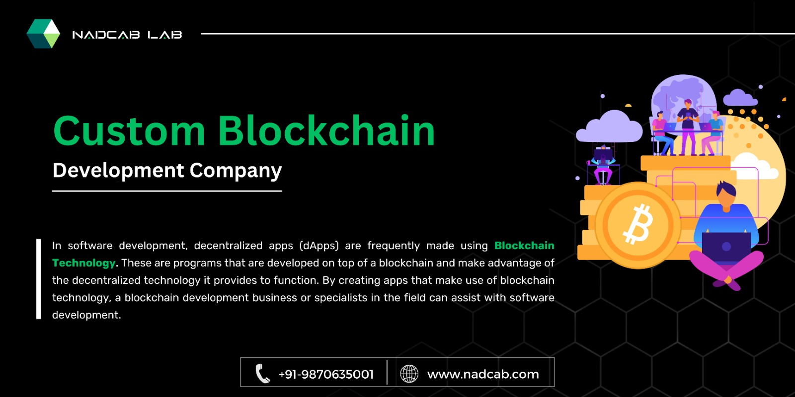
7.DApps: Operating on decentralized networks free from single points of manipulation, decentralized applications, or dApps, take advantage of the blockchain era to increase security and transparency. They promise censorship-resistant and trustworthy solutions that have the potential to completely transform a variety of businesses by using clever contracts to automate procedures in the banking, gaming, and delivery chain industries.
8. Cross-chain bridges: Enabling smooth communication across private blockchain networks, cross-chain bridges consider the movement of assets and data between several networks. The protocols enhance the functionality of decentralized applications (dApps) and decentralized finance (DeFi) by surmounting challenges such as scalability and lack of interoperability. This allows for the crucial go-chain asset transfers and token swaps that unlock the full potential of the blockchain industry.

The Transformative Potential for Businesses

Enhanced Security: Custom blockchain solutions reduce the risk of fraud, data breaches, and unauthorized access by using cryptographic hashing and decentralization to provide a higher level of protection.
Increased Transparency: Due to the immutability of transactions and records and their accessibility to authorized users, the inherent transparency of blockchain technology promotes agreement between parties.
Improved Efficiency and Speed: Blockchain can significantly lower transaction instances and improve operational performance by automating procedures and eliminating middlemen.
Cost Reduction: The initial outlay for blockchain development can be substantial, but there will be long-term benefits in terms of transaction fees, reconciliation, and fraud protection.
Innovation and Competitive Edge: By implementing customized blockchain solutions, companies can open up new markets and opportunities and project themselves as visionary leaders.
Choosing the Right Custom Blockchain Development Company
A blockchain venture's success can be determined by making a critical choice when choosing a development associate. Companies should keep in mind the following:
Expertise and Experience: Seek out companies who have a track record of success in creating blockchain solutions across a range of industries.
Technical Proficiency: Make sure the team is extremely knowledgeable in coding languages, smart contracts, blockchain protocols, and consensus techniques.
Strategic Approach: The ideal partner will integrate blockchain technology with the needs of the commercial company by offering strategic insights rather than just technical execution.
Portfolio and Case Studies: Examine more than just case studies and projects to determine whether the employer can provide cutting-edge, effective solutions.
Client Testimonials and References: Previous customers' reviews can provide essential information about a company's dependability, promptness, and quality of service.
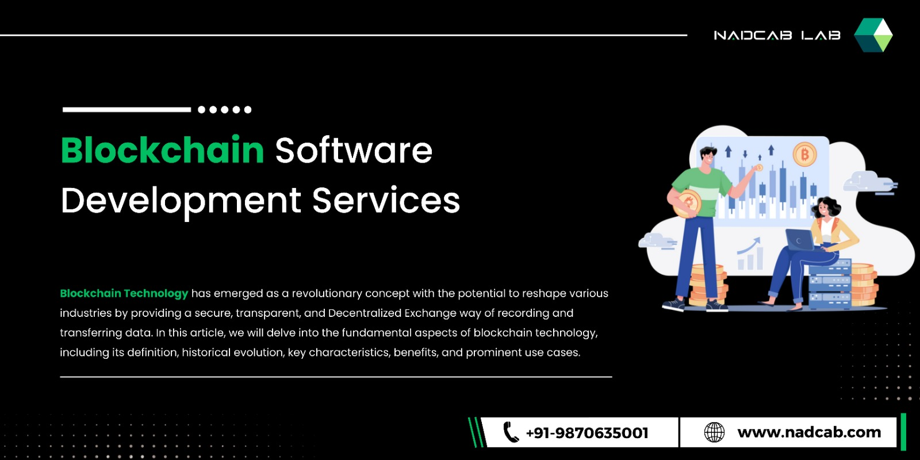
Conclusion
The adoption of blockchain technology is intrinsically linked to the fate of business and generation. At the forefront of this change are custom blockchain development companies, offering customized solutions that open the door to a more stable, transparent, and productive world. Businesses may fully utilize blockchain technology to generate growth, innovation, and competitive advantage in the digital era by collaborating with the right development company.
Facebook: https://www.facebook.com/nadcablabs
Linkedin: https://www.linkedin.com/company/nadcablabs/
Instagram: https://www.instagram.com/nadcablabs/
Twitter: https://twitter.com/nadcablabs

