Retailing done Right

with

Microsoft Dynamics
365

Important factors to keep in mind while considering an investment in enterprise business software

DEL7EREICEPTI0NALRETA?E PERENCET6ATELE7ATEY0URST0REAND

POINTOFSAIEOPERATIONS
Earlier it was just the Internet, fast forward now, we have a convergence of big data, cloud, and the Internet of things ( IoT] that is creating possibly new highways to making sense of the large data available, throwing in new challenges and business opportunities at the same time. Today systems and applications are designed to capture, store, process, analyse data in a manner that can provide valuable insights and benefits for quick and well informed decision making.
There are technology that helps you to map every part of the customer experience pushing Retailer to be responsive to enhance the customer journey and offer more than expectations. Customers are expecting capabilities from enterprise that will woo them with more.
The Retail applications of Microsoft Dynamics 365 with the combined power of ERP and CRM , offers just the key tools to cater to the ever-changing digitized market

THE EVERCHANGING ECO SYSTEMS

Must haves for a happy shopper ...
Mobile responsive site, ease of access and downloads, shop on the go, secured and easy to pay options, cross device cart functionality, consistency and speed of service.
Personalised service and reward programs.
In today's world, retailer encounters with many challenges, from managing daily operations at their stores to transforming their business for future growth
Retailer needs solution that is secure, scalable and cloud engineered. A simplified solution that is easy to deploy, configure implement and operate.

Systems and applications that support
- 0mni-Channel Operations
- 360 degree insight of the customer
- Supply chain optimisation
- Finance and Accounting management
- Inventory management
- Agile Technologies adaptation
- Localization
- Safer, Quicker and faster deployment
- IoT Enabled & seamless integration across platforms and
solutions
- Data driven Analytics

K • RCOMPTENZ
www.korcomptenz.com RETAILING DONE RIGHT 2

WHATlSMlCR0S0FTDYNAMlCS365?
Microsoft Dynamics 365 is unique, powerful business software that bas the functionality and benefits of both customer relationship management (CRM) and enterprise resource planning (ERP). The platform includes applications that address the full range of business processes including Sales, Customer Service, Finance and Operations, Field Service, Marketing, Human Resources, Retail, and Customer Insights.

H0WDYNAMlCS365lSUNl0UET0RETAlLlNG?
Microsoft has introduced Dynamics 365 Commerce in order to address the needs of retailers. It has the following features which makes it unique to not only retailing but eCommerce as well.
  - Ease of access to real time information
  - Omnichannel capabilities Global reach and localisation
  - Mapping Customer Journey's to enable enhanced engagement
  - Customer Insights that cater to what's important and relevant
  - Accelerate Operational efficiency that keeps you on track with the strategy to prioritize growth
  - Data that helps in tracking KPI
  - Future Ready solution integrating all dynamics of business
  - Cloud and on premises capabilities

K • RCOM.„mP.„Ta.E.xN,r,Zi, www.korcomptenz.com RETANNG DONE RGHT 3

WHY MICROSOFT DYNAMICS 365?
  - Dynamics 365 Commerce, formerly Dynamics 365 Retail helps retailers get ahead in today's competitive environment that drive their retail operations, deliver a connected employee experience, and delight customers with exceptional shopping experiences resulting in positive business impact
  - Real time data information at your finger tips
  - Cloud based solutions that reduces the cost of on premise infrastructure
  - Microsoft PowerApps and Power Automate allow self-service customization and improved mobility
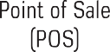
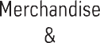

CHALLENGES OF RETAILING

- How to empower HD users, Store managers and front line Operators ?
  - How to tackle the omnichannel dilemma of accessing relevant data; inventory visibility and availability, security and payments.
  - How to manage store level execution which may include managing day to day operations and labour or vendor management
  - How to manage and drive sales seamlessly — online, instore, shipment
  - How to streamline operations — supply chain and logistics
  - How to build the Next generation experience for your shoppers consistently in the digital space

K • RCOM.„mP.„Ta.E.xN,r,Zi, www.korcomptenz.com RETAINNG DONERIGHT 4

HOWDOESDYNAMICSRETAILINGANSWERSTHEPAINPOINTS?

Microsoft Dynamics maps and integrates your key business operations seamlessly:
Makes each function talk to each other

¥darehouse
Suppliers

Dispatch to stores as needed

Modile Sales, Dashboards, Collabo ti App

Mofiile Sales, Dashboards, Collaboration, Approach

Sales & Marketing
Retail Corporate
Regional Offices

Nobile Sales, Dashboards, Collaboration, Approach
Merchandiser

Real-time Mobile Shop & Consumer Purchasing & Store inventory statistics

Retail Stores

Real-time P°romoetions, Coupons information & other incentives

Get mobile consumers

Consumers
Delight the Mobile Shoppers
Loyalty Program Management, Shopping Cart,
Store Locator, Coupons 8 Advertising, Alerts 8 notifications

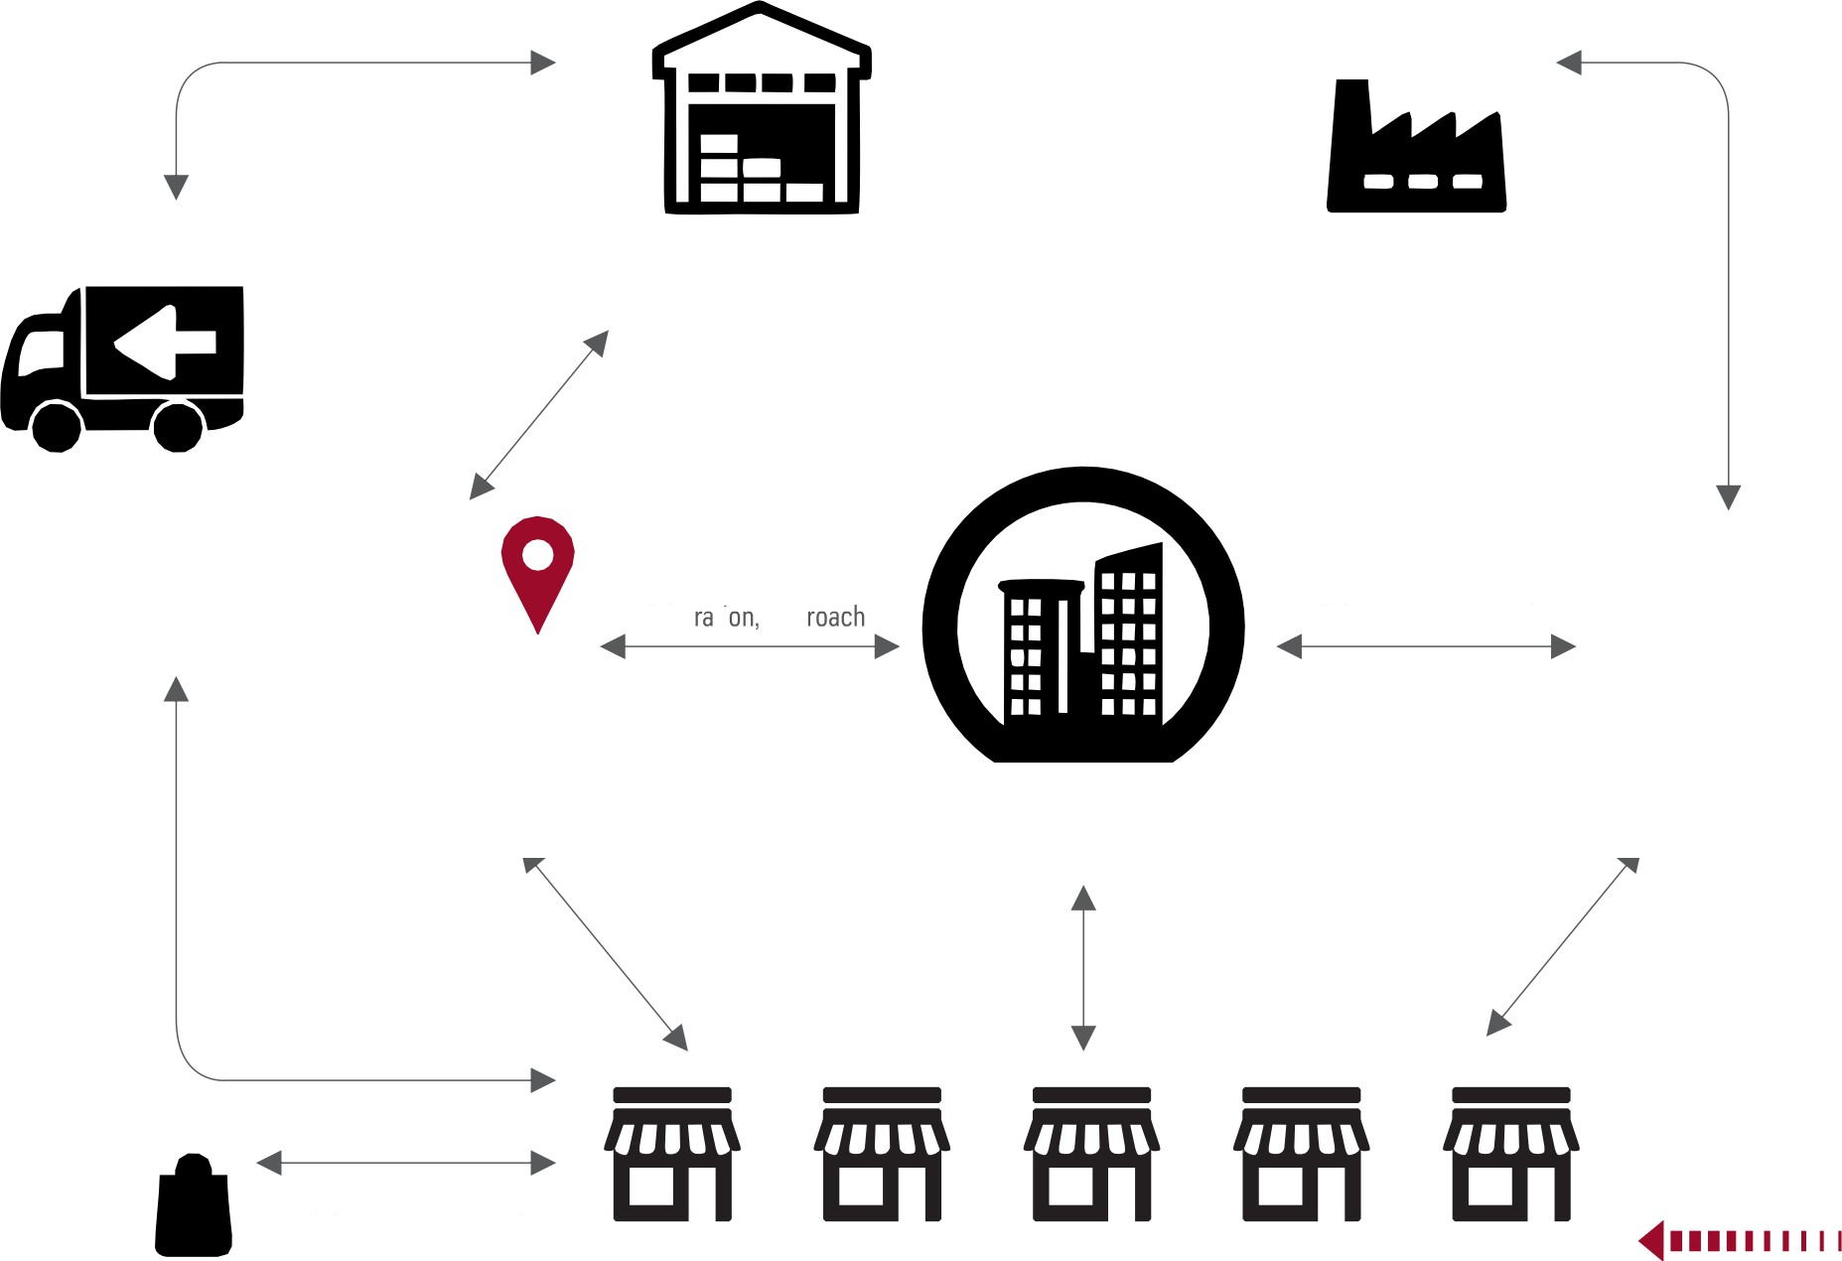
KO•RCOMPTENZ
www.korcomptenz.com
RETAILING DONE RIGHT 5

Microsoft Dynamics provides you with seamless Omnichanne! and commerce
excellence
Empowers Retailers to service empowered shoppers

C0NSUMER?0URNEY MAPPING
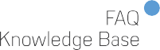

Radio, TV,
Print
Ecommerce

Microsoft Dynamics gives a real view of resources and process to handle costs around functions of replenishment, order management, warehouse and transportation logistics

ENABESKEYBENETS

Products & Variants
1 2 3 4 5 6

Barcodes

Labels Mass Updates
and Bulk Editing

Product Kits

Attributes Framework
7@f@l0g

Management
Assortment
Management
Pricing &
Discounting

Microsoft Dynamics helps create a digitized operations around your retail outlets and store operations to enable interactive displays, assisted selling, assortment & Catalog management, merchandising and planning

Microsoft Dynamics 365 Commerce and Common Data Service
Dynamics 365 Commerce allows for easy integration with other Dynamics 365 products such as Dynamics 365 Sales and Dynamics 365 Marketing through the use of a shared common data service.

This Data service also allows transactional data to be used to power various analytics and insight scenarios in the Dynamics 365 Commerce solution.

DYNAMICS 365 COMMERCE ARCHITECTURE
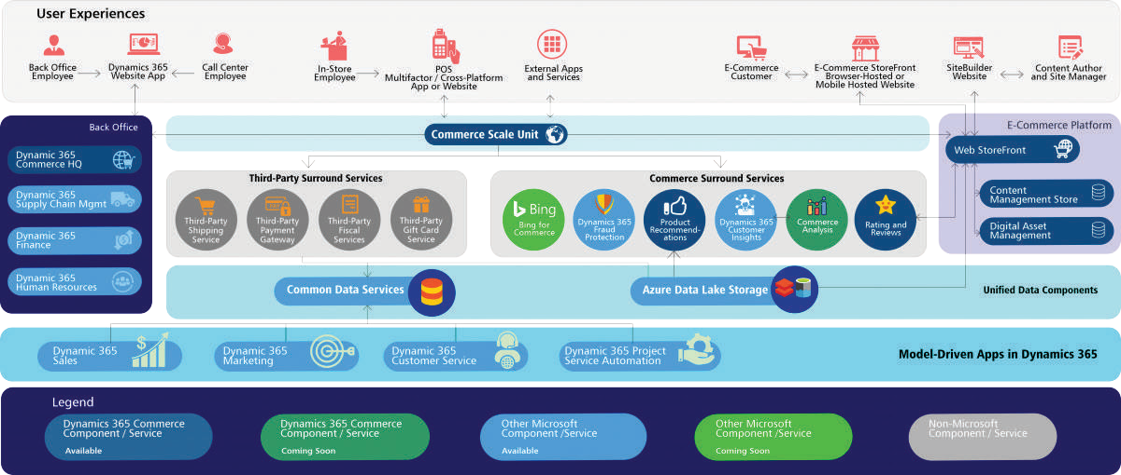

The Dynamics 365 Architecture offers many benefits to the user. The benefits are:

Omni-channel enabled headless commerce engine
The platform has a headless commerce engine which powers a complete omni-channel solution across physical and digital stores.

Interconnected business processes
Dynamics 365 Commerce can be shared among the various Microsoft Dynamics Applications allowing users to have a set of interc0nnected business processes that users can immediately benefit from.

- Unified Data
It provides the users with a unified view of the data through out-of—box integrations with the Common Data Service and Azure Data Lake Storage. The Common Data service allows the sharing of data between the Microsoft Dynamics 365 Applications and Dynamics 365 Commerce. The Data Lake is used to power analytics in the Dynamics 365 Commerce Solution.

- Powered by AI and Analytics
Due to the existence of a unified data system, the users can derive insights and get key performance indicators KPIs) that can be used optimize and automate business processes across all channels.

Korcomptenz Capabilities on Microsoft Dynamics 365

Korcomptenz has been providing Microsoft dynamics services for over 6 years

Our commitment is to work for your success—we strive to identify the ideal solution for your specific needs, engage the best possible resources with the right skills and experience, and deploy it an Optimal fashion to realize the highest DSSÎbIe return on investment

CUSTOMER ENGAGEMENT
- Omni-channel Commerce
- Dynamic promotions
- Multi-channel order fulfilment
- Loyalty Management

WE'RE HERE TO HELP
ENTERPRISE EFFICIENCY
- ERP Implementation
- Application Upgrade
- POS solutions
- Merchandise Analytics
IT COST MANAGEMENT
  - AMS
  - Li, L2 & L3 Support
  - Network Support
  - Infrastructure support

KORCOMPTENZ is your total technology transformation partner, helping you engage your customers and prospects, enable your business, and accelerate your results. Request a consultation to learn more about our web and marketing technology services, business management solutions, mobile apps and custom development, and infrastructure management services.

K RC@IÂR!TI8BIZ
- ENGAGE • ENABLE • ACCELERATE

www.korcomptenz.com
100 Valley Road, Suite 102
Mount Arlington, New Jersey 07856
United States
1-973-601-8770
DISCLAIMER: The content provided in this document is intended solely for general information purposes. The content was compiled with reasonable care and attention at the time of its release. However, it is possible that some information in this document incomplete, incorrect, out-dated, or inapplicable to particular circumstances or conditions. KORCONPTENZ does not accept liability for direct or indirect losses resulting from using, relying or acting upon information in these documents.
This document may content logos, trademarks, service marks or other insignia owned by third party organizations. The use of any such items does not constitute an endorsement, sponsorship, or any formal association with the respective owner. The respective owner retains all rights and title to their intellectual property.

